**Calories Consumed :**

Weight gained is our output which is continuous and a single input variable it implies simple linear regression.

Output (Y) : weight gained

Input (X) : calories consumed

**R Code:**

**# Load the library**

library(readr)

**# Load the csv file and stored in object calories_consumed**

calories_consumed <- read_csv("D:/ALL Assignments/3.Simple Linear Regression/calories_consumed.csv")

**# attach the object**

attach(calories_consumed)

**# Draw scatter diagram**

plot(Cal, Wgt)

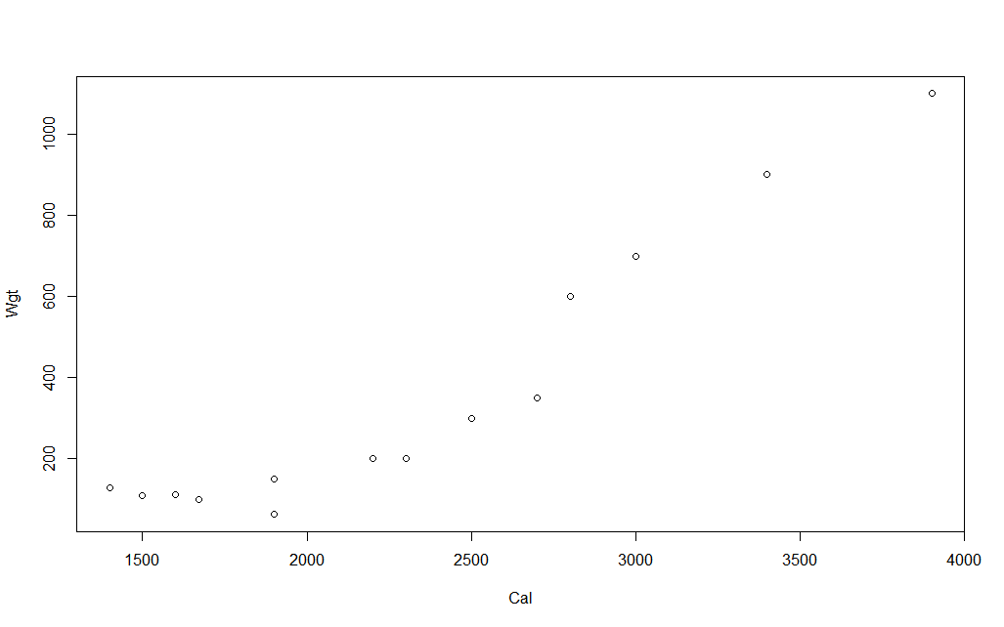

It tell following things:

I) Direction : positive correlation

II) Strength : moderate to strength

III) Linearity :Linear relationship

**#Correlation coefficient r :**

Cor(Cal,Wgt)

It give r = 0.946991

As r > 0.85 => Strong strength

**#Linear regression technique and its summary**

calories_model <-lm(Wgt~Cal)

summary(calories_model)

It gives:

Call:

lm(formula = Wgt ~ Cal)

Residuals:

Min 1Q Median 3Q Max

-158.67 -107.56 36.70 81.68 165.53

Coefficients:

Estimate Std. Error t value Pr(>|t|)

(Intercept) -625.75236 100.82293 -6.206 4.54e-05 ***

Cal 0.42016 0.04115 10.211 2.86e-07 ***

---

Signif. codes: 0 ‘***’ 0.001 ‘**’ 0.01 ‘*’ 0.05 ‘.’ 0.1 ‘ ’ 1

Residual standard error: 111.6 on 12 degrees of freedom

Multiple R-squared: 0.8968, Adjusted R-squared: 0.8882

F-statistic: 104.3 on 1 and 12 DF, p-value: 2.856e-07

As we are getting three stars(probability of getting wrong is less) and R-squared value is also greater than 0.8 indicates an overall strength of model is strong.

Final equation :

**Weight gained = -625.75236 + 0.42016(Calories_consumed )**

**R-squared = 0.8968**

**RMSE =**

sqrt(sum(calories_model$residuals^2)/(nrow(calories_consumed)-1))

#RMSE[1] 107.2021

**Confidence Interval estimate:**

**Confidence interval =95%**

**confint(calories_model,level = 0.95)**

This gives;

confint(calories_model,level = 0.95) 2.5 % 97.5 %

(Intercept) -845.4266546 -406.0780569

Cal 0.3305064 0.5098069

**Lower Range:** -845.43 + 0.33050(Calories_consumed)

**Upper Range:** -406.07805 + 0.50980(Calories_consumed)